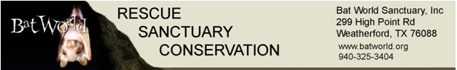
Peekaboo Rescue Fund Application
Grant applications may be submitted throughout the year. Grants are typically awarded in March and September each year.
Name_______________________________________________________________________________
Address______________________________________________________________________________
Home Phone___________________________ Cell Phone___________________________________
Email________________________________________________________________________________
Qualifications:_________________________________________________________________________
Rehabilitator since_________ State/Federal Permits held__________________________________
Description of how funding will be used for the project and or activity ___________________________
_____________________________________________________________________________________
_____________________________________________________________________________________
_____________________________________________________________________________________
Amount of funding needed $_________________
On a separate piece of paper, write a narrative description of how funding will be used for the project. Include descriptions. diagrams, material cost/budget, location, goal, completion date, and benefit to the applicant and to bats and/or bat rehabilitation.
Projects must be completed within 6 months of the grant award.
Send application, narrative, and supporting documents to the Bat World Board of Directors via email to both sanctuary@batworld.org and bwmidcities@batworld.org. All applications must be submitted electronically. Incomplete applications will not be accepted. Grant recipients will be notified by email.

