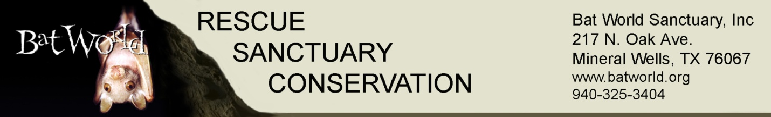

Bat World Sanctuary

Program Proposal for
[Sample] Wildlife Rehabilitators and Veterinarians

Bat World Sanctuary will present a class on bat rehabilitation basics for ______ wildlife rehabilitators and veterinarians. The program details are as follows:

- Advance registration is required for the rehabilitation skills workshop. Students may register at https://batworld.org/national-workshops/. The registration deadline will be 30 days prior to the scheduled workshop, to allow Bat World sufficient time to prepare the correct quantity of training materials

- General Bat Lecture (optional) – Date and time TBD depending on availability of venue and level of interest. This portion of the program is open to the public as space permits and lasts 90 minutes. Admission is $10 per person and is suitable for adults and children age 10 and up. Not suitable for children under age 10. Pre-registration is not required. No live bats will be used in the presentation; I will be available for Q&A afterward. One half of the admission proceeds will be donated to the host’s designated non-profit bat rehabilitation organization or a general wildlife rehabilitation organization

- Bat Rehabilitation Basics (Day 1) – This workshop is scheduled for 8 hours, 9 AM – 5 PM (includes working lunch). The cost per participant is $250 and includes all course materials and lab supplies for both days. Maximum registration is 25 attendees. Topics include:
  - Species Identification
  - Talking to the public
  - Safe handling techniques (hand-on lab with live if available)
  - General intake exam (hands-on lab, cadaver and live if available)
  - Housing
  - Enrichment
  - Feeding/nutrition (hands-on lab with live if available)

- Medical Management (Day 2) - This workshop is scheduled for 8 hours, 9 AM – 5 PM (includes working lunch)
  - Rabies and public health discussion
  - Identifying long-term care cases
  - Hydration and injection techniques (hands on lab, cadaver)
  - Medical management (hands on lab, cadaver)
    - Dental procedures
    - Stabilizing simple radial fractures
    - Stabilizing simple humeral fractures
    - Compound radial fracture repair
    - Compound humeral fracture repair
    - Preparing specimens for necropsy
    - Review of unusual cases

- Because of the logistics of transporting live animals across state lines, we will not be bringing live bats for this program.

- Cadaver specimens for the hands-on lab activities will be supplied by the host/participants. In the event that the host/participants is unable to provide a sufficient number of cadaver specimens (one per participant plus two for each instructor), the host will obtain the necessary permits for Bat World Sanctuary to ship frozen cadaver specimens from Texas to __________. Specimens or permits must be confirmed at least two weeks in advance of the class, in order to allow for shipping time.

- Injection practice supplies will be supplied by BWS (one 3-cc syringe and one 25g x 5/8” needle per participant, plus one for each instructor; sharps container, LRS or equivalent injection solution), and will be shipped to the host in advance

- Medical Management Lab supplies will be shipped to the host in advance

- Books and other student handouts will be shipped to the host in advance.
- The host/participants will cover all travel expenses for the instructor.

- The host will receive all advance shipments and will ensure that all materials are delivered to the workshop site, directly to the instructor, upon their arrival.

Estimated Costs

- Instructor travel expense (coach/economy airfare, round trip, DFW to class location, hotel, rental car) $800
- Meeting room expense – TBD, depends on date and location
- Class material shipping -- $200 (all materials will be shipped USPS flat rate Priority Mail with insurance)

Participant costs

- Class fee of $250 per person, covers both days
- Share of workshop costs (instructor expenses, meeting room expense, class material shipping), host’s discretion
- Individual travel expense to class location

