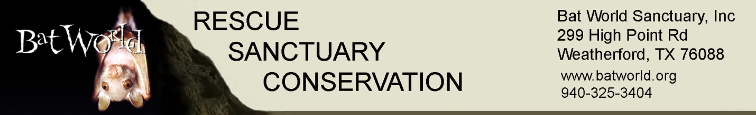

Custom Bat Rehabilitation Workshop Request
Please read the sample proposal on our National Workshops page for planning guidance and host responsibilities. Please note we require at least six months lead time to schedule a custom workshop.
Name of Hosting Organization: __________________________________________________________
Contact Name: ________________________________________________________________________
Contact Phone: _______________________________________________________________________
Contact email: ________________________________________________________________________
Location: ____________________________________________________________________________
Location Address: _____________________________________________________________________
Location City, State, Zip: ________________________________________________________________
Desired Date(s): _____________________ _____________________ ________________________
(Please provide three date options for your workshop)
Based on the planning guide, confirm you are able to provide:
Minimum of 12 attendees (maximum 24) _______
Meeting room ________
Cadavers (minimum one per attendee plus 2 for instructor) ________
Live bats if available _________
Instructor fees and shipping costs as outlined in the planning guide ____________

